

**PROJECT REPORT**

**Teamwork: Do Thi Loan - Student1415796**

**Pham Nhu Son - Student1425110**

**Tran Duc Thang - Student1415768**

**Ngo Hoang Yen - Student1424540**

**Eproject title: website to display and sell handicrafts**

**Duration of the projects:**

* **Start Date:  16-June-2023**
* **End Date: 04-Aug-2023**

**Air Conditioners Retail Store**

1. Problem definition

Venus Handicrafts is a certified company engaged in manufacturing and exporting of Decorative Handicrafts to global importers, wholesalers and retailers since 1972. The ever-increasing acceptance of our products on global platforms highlights our market presence and goodwill. The company has maintained its market value throughout the world. To enhance its value the organization wants to change the look and feel of the website for which they have approached you. You are supposed to create a website for them with the below mentioned requirement specifications. The website is to be developed for the Windows Platform using HTML5, JavaScript and Geolocation. The site should work well in all leading browsers including Chrome,IE, Firefox etc.

1. Function

Our page is designed as a Single-Page-Application and responsive Website with a set of pages and menus that represent choice of activities to be performed.

Following are the functional requirements of the portal:

**1. Page:** Display menu include: Home, Introduce, Photo Library, Contact, Handicraft Products, Site Map, FAQS, etc... Home page showing the highlights of the company Venus Handicrayts

**2. About:** About the company profile and the origin and origin of the product

**3. Librarying :** Photo Gallery is a place to collect photos of famous handicrafts at home and abroad, welcomed and expected by many visitors.

**4. Contact :** Contains a form to contact the company with product recommendations requested by the customer. Along with that is the specific address of the company and phone number, and some other contact methods

**5. Handicraft Products :** Contains a list of the company's products displayed at the site. With diverse designs and rich sources from all over the world. Products will be directly contacted by customers with the company, meeting and exchanging more clearly.

**6. Sitemap :** Works based on maintaining a list of products within the company, products displayed as well as sold at e-commerce platforms or auctions.

This is a directory of all the company's products.

**7. FAQS :** This acts like the Customer Care service, which is available 24/7 to the users in case of any query. Include: our mail, location, phone number and other contact information.

**8. LOGIN :** designed as a regular registration and login form. But is used as a place to receive customer feedback about products, customer service, personal opinions of customers with products, websites including companies, employees, ...

1. Hardware

**1. Hardware**

* Intel Core i3/i5 Processor or higher
* 8 GB RAM or above
* Color SVGA
* 500 GB Hard Disk space
* Mouse
* Keyboard

**2. Software**

Technologies to be used:

• Frontend: HTML5, CSS, Bootstrap, JavaScript, jQuery, AngularJS, XML

• Data Store: JSON files

Other Requirements:

• Operating Portal: Windows

• Browsers: Edge, Chrome, Mozilla Firefox, Safari

1. DFDs

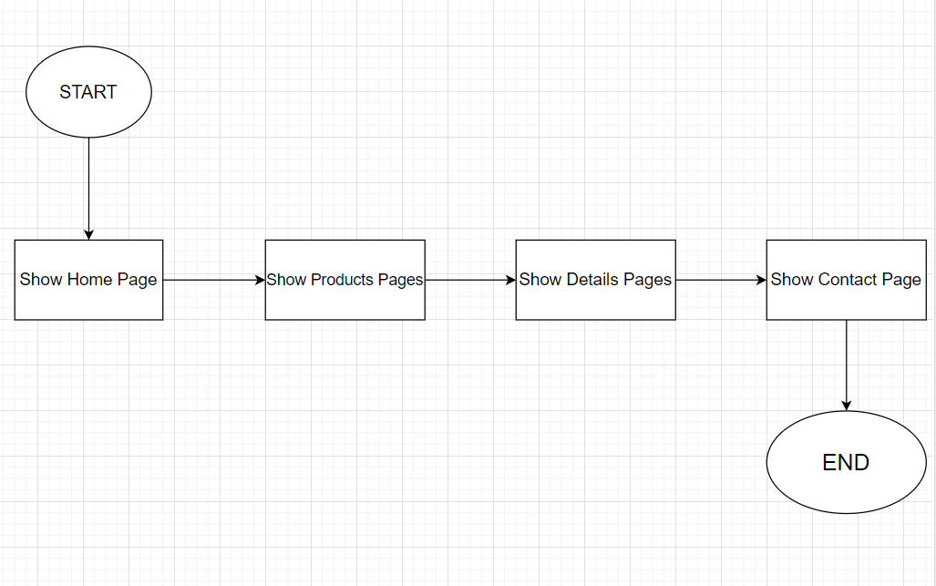

1. Flowchart
2. 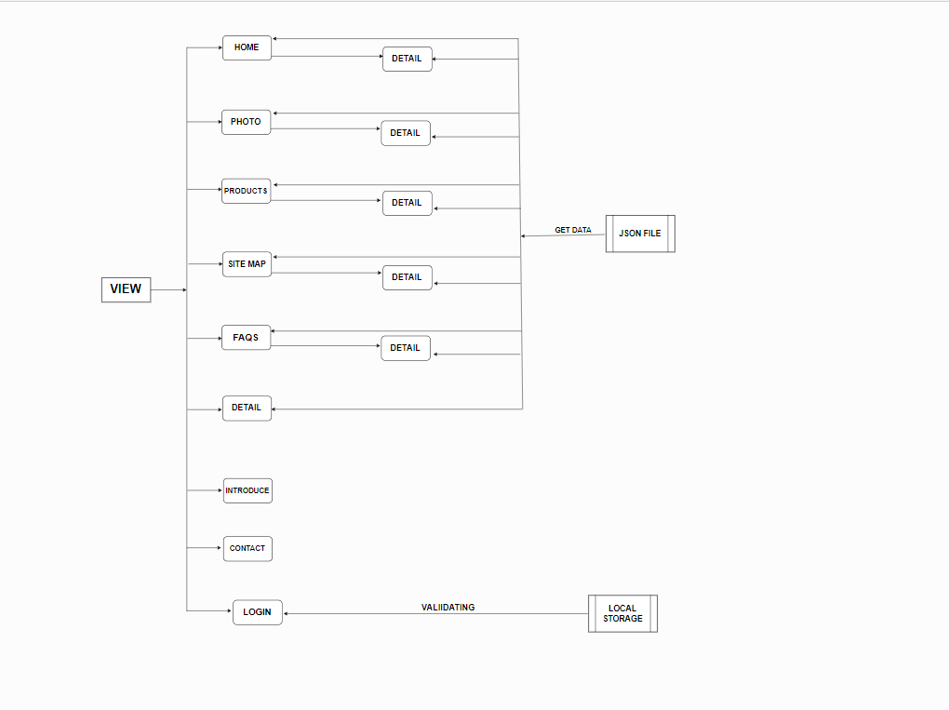
3. Some typical interface

* HOME PAGE

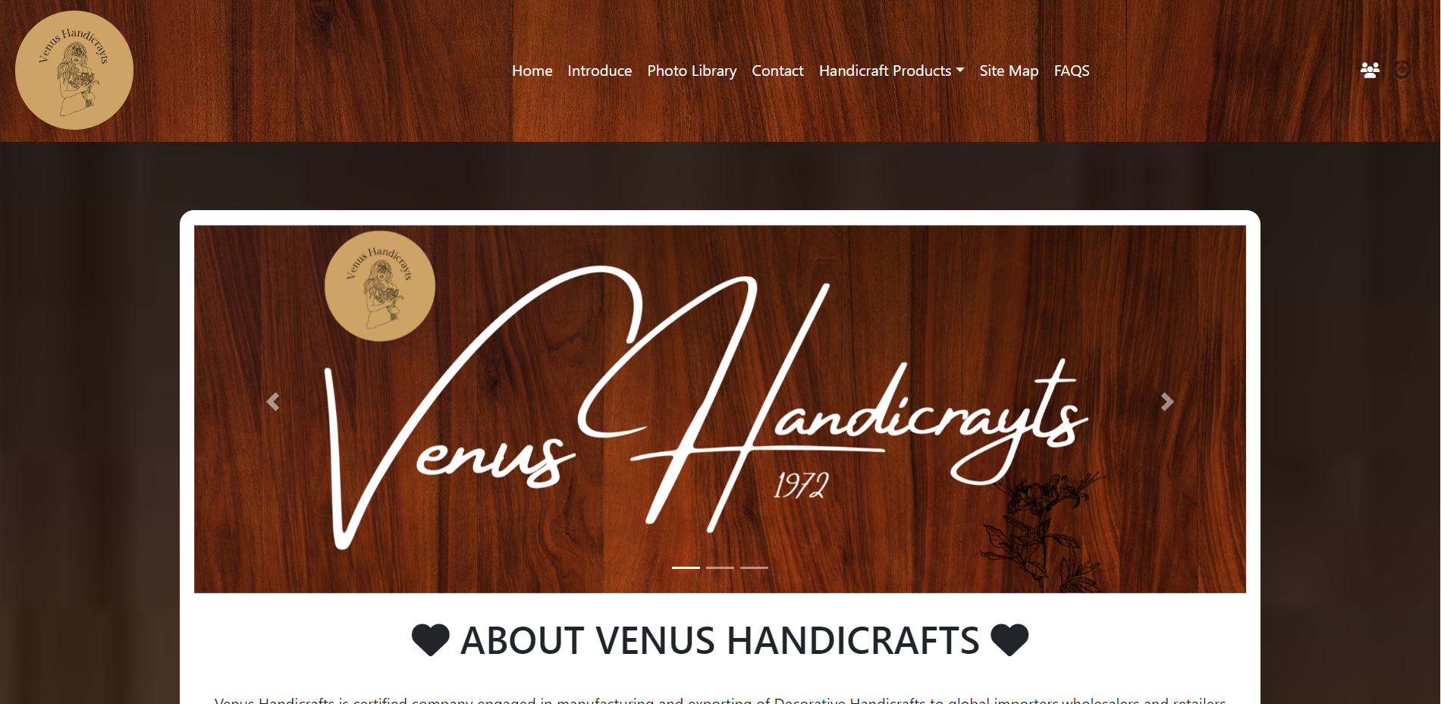

* INTRODUCE

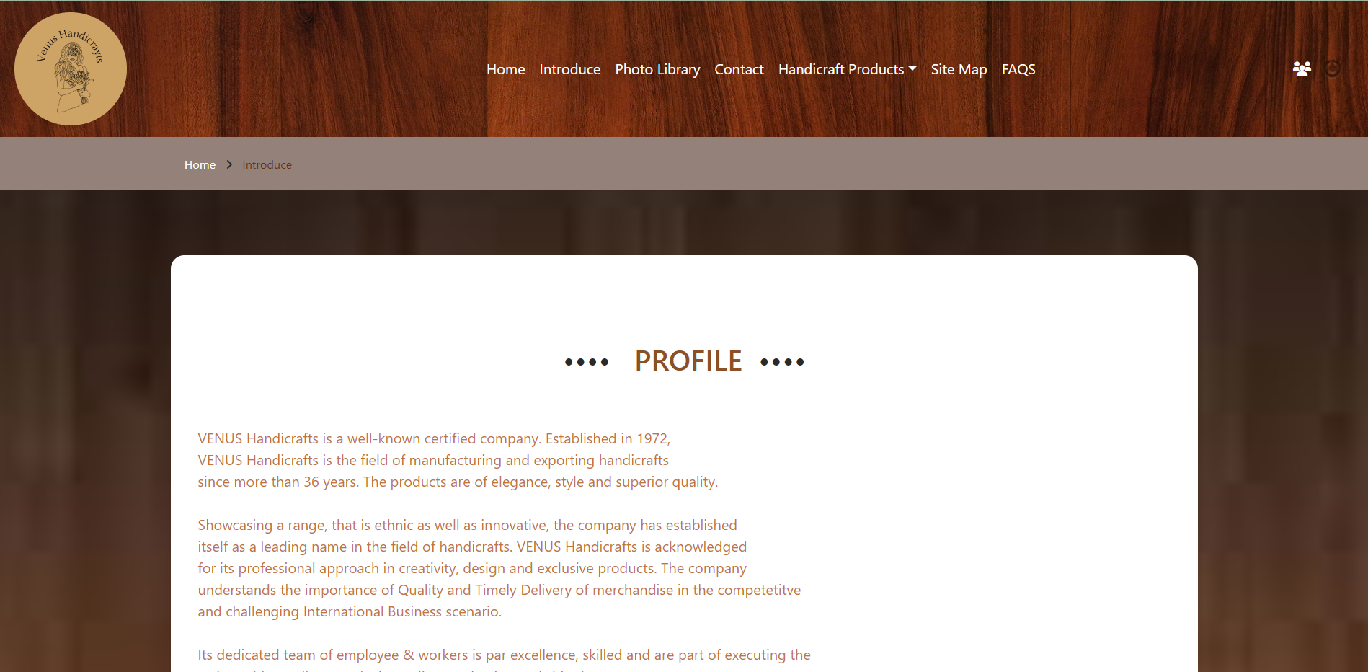

* PHOTO LIBRARY

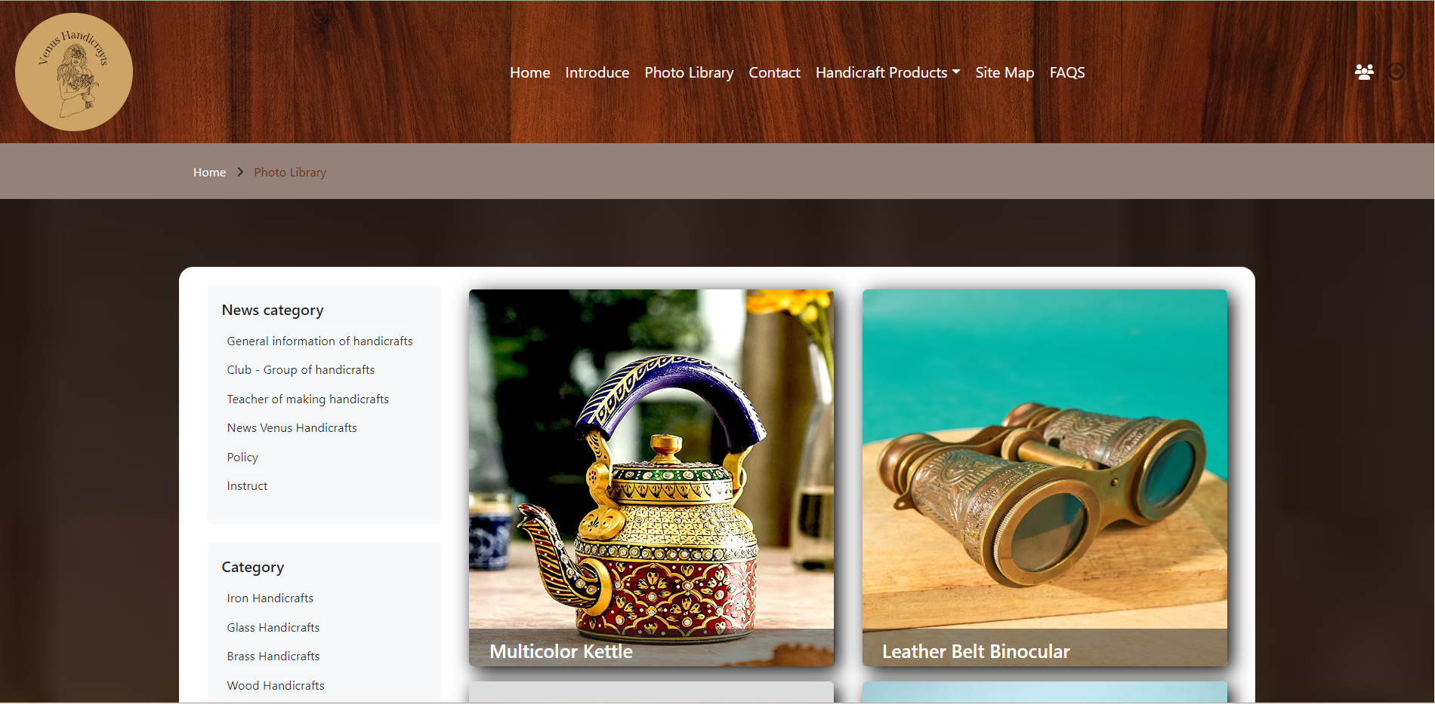

* CONTACT

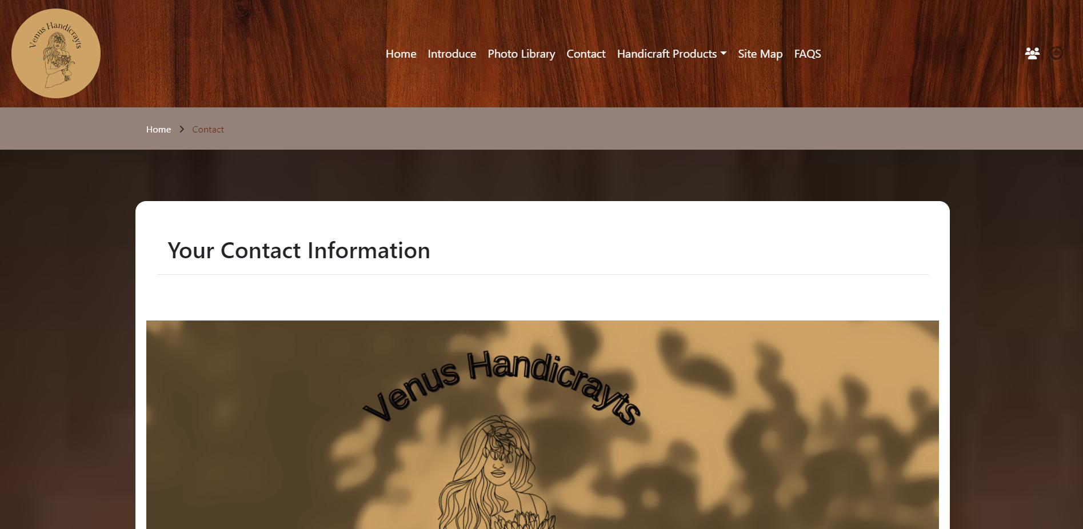

* HANDICRAFT PRODUCTS

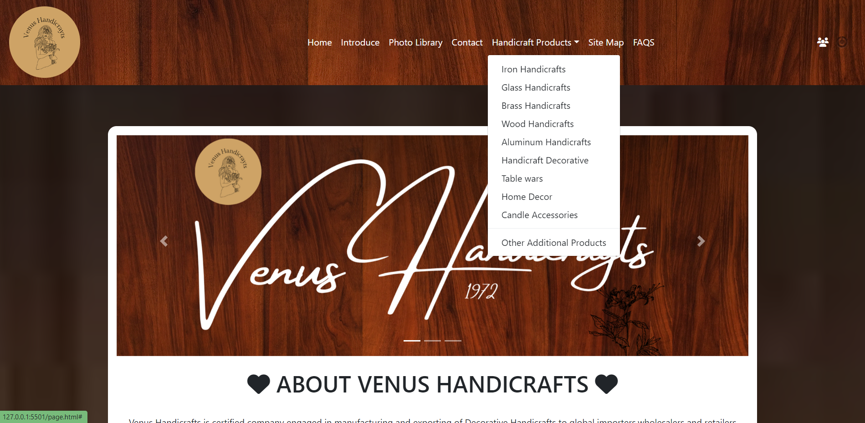

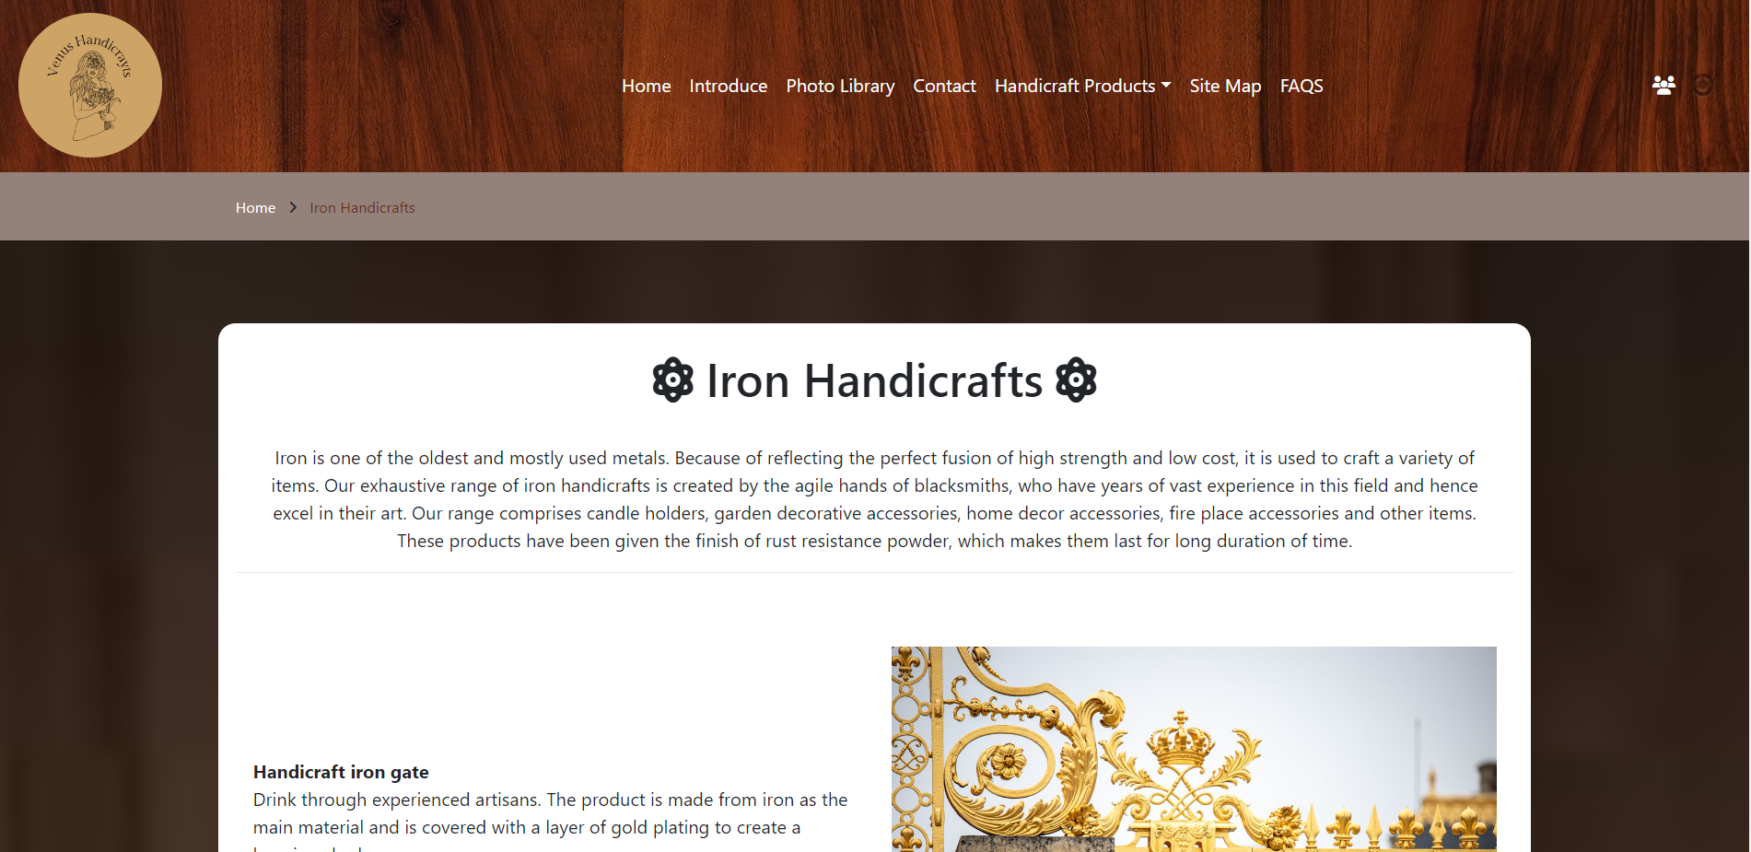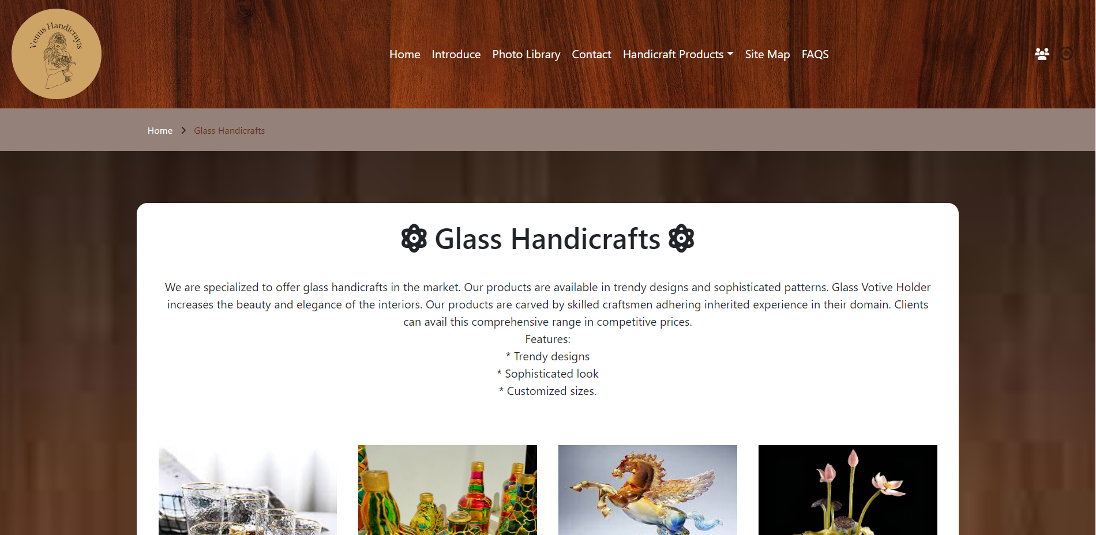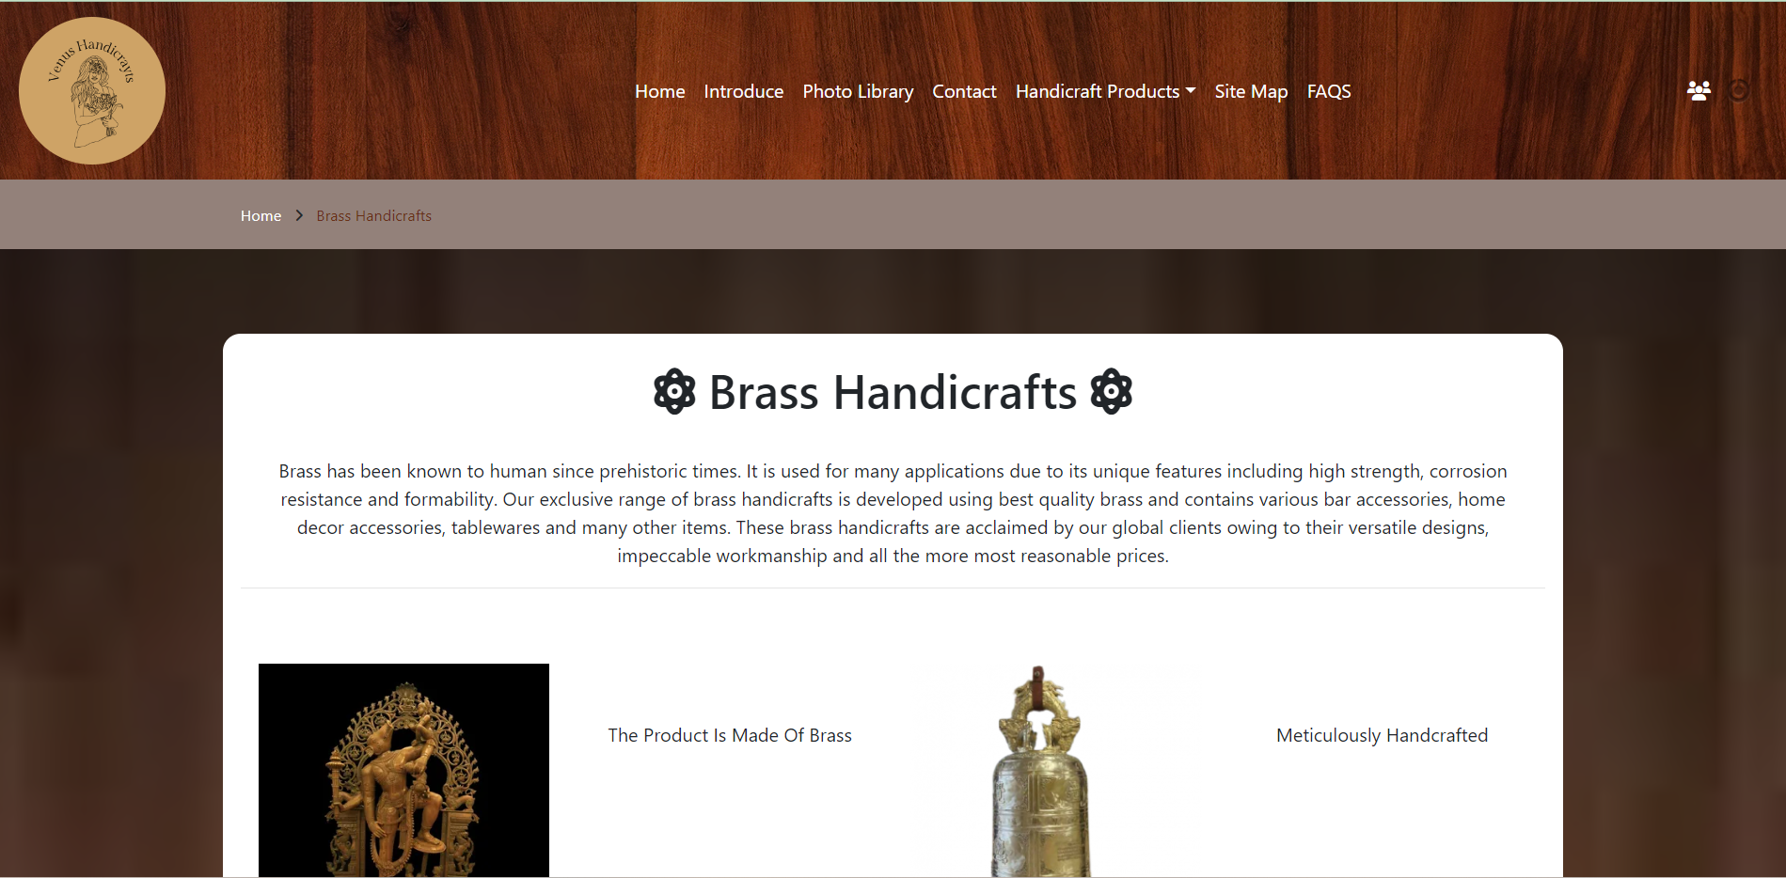

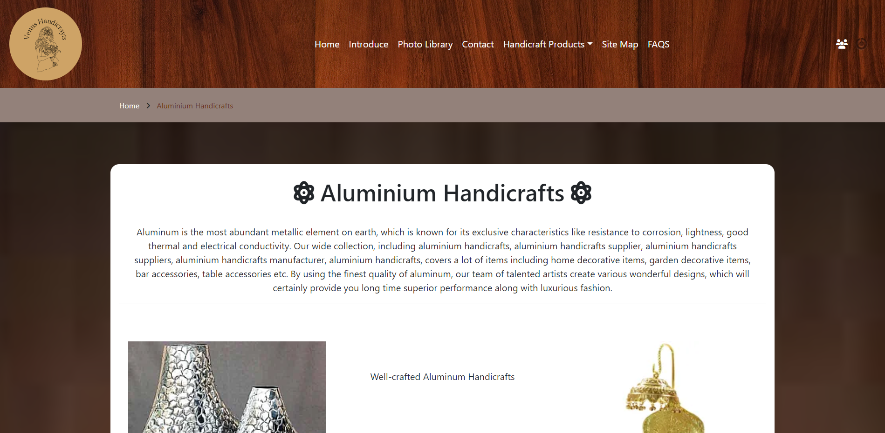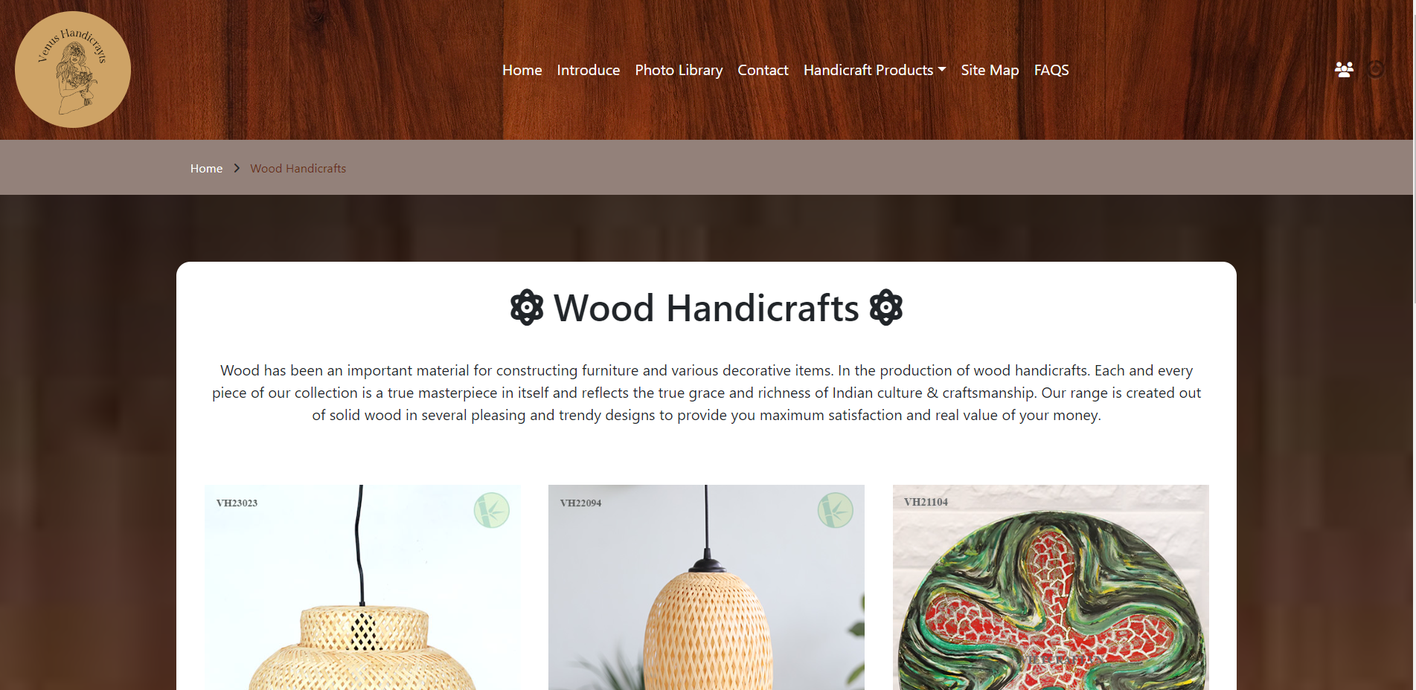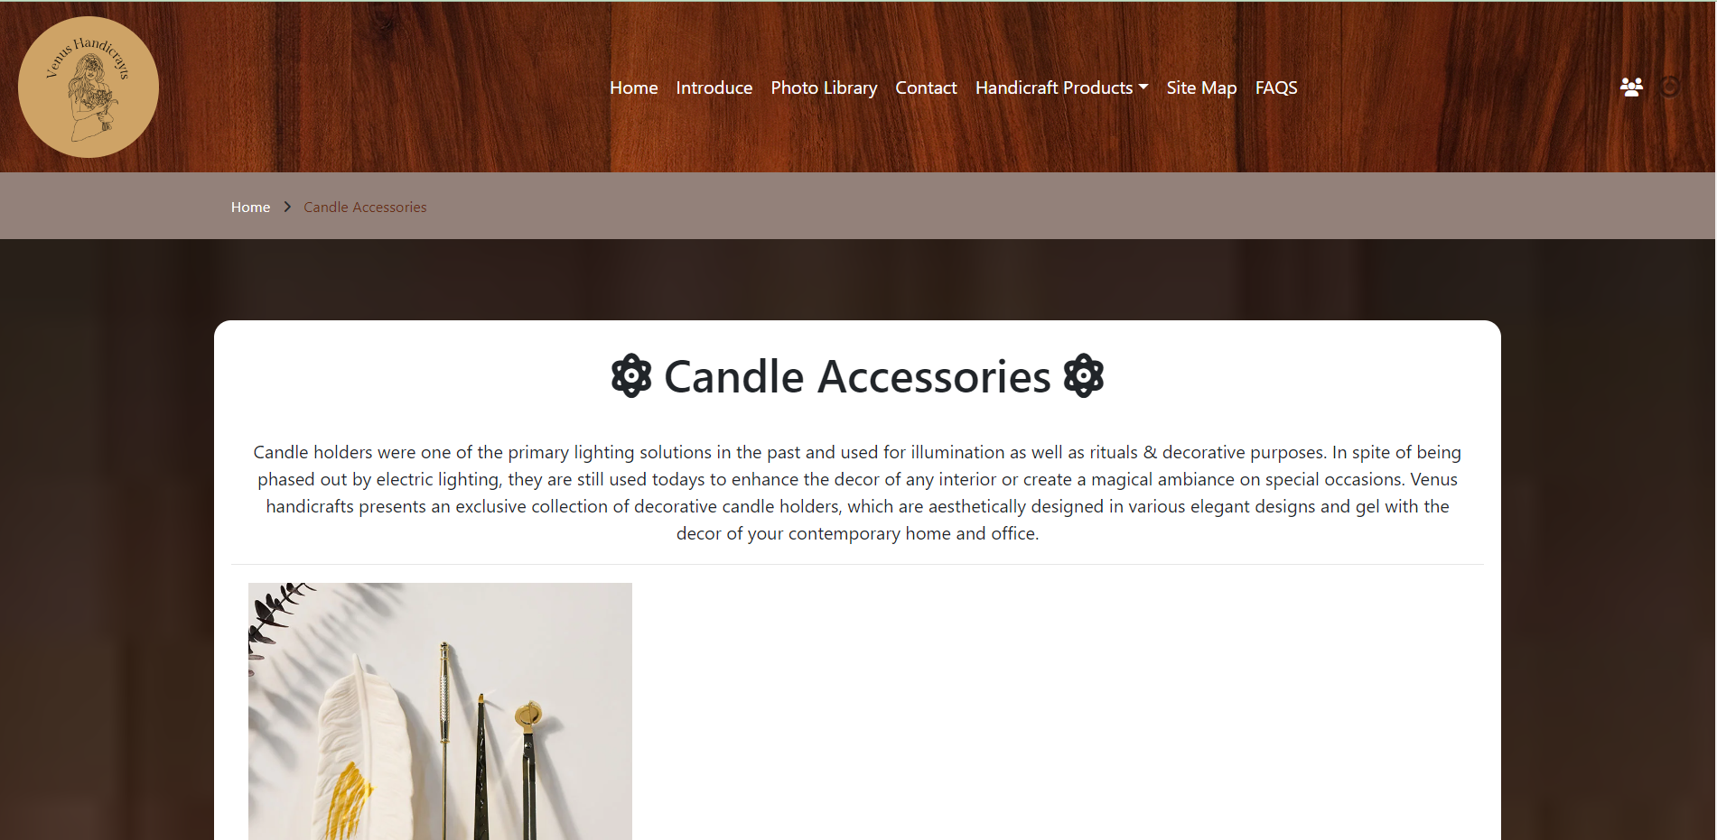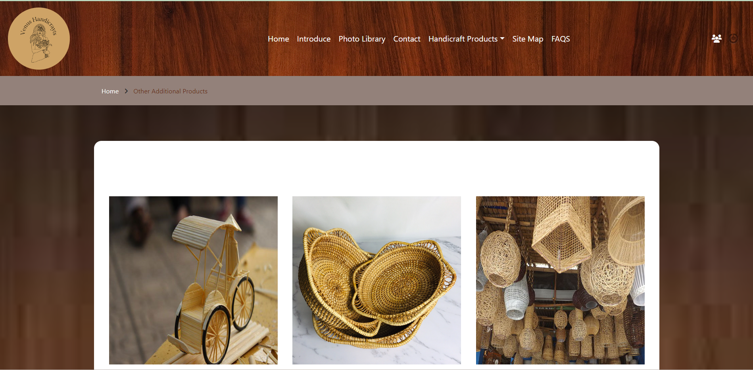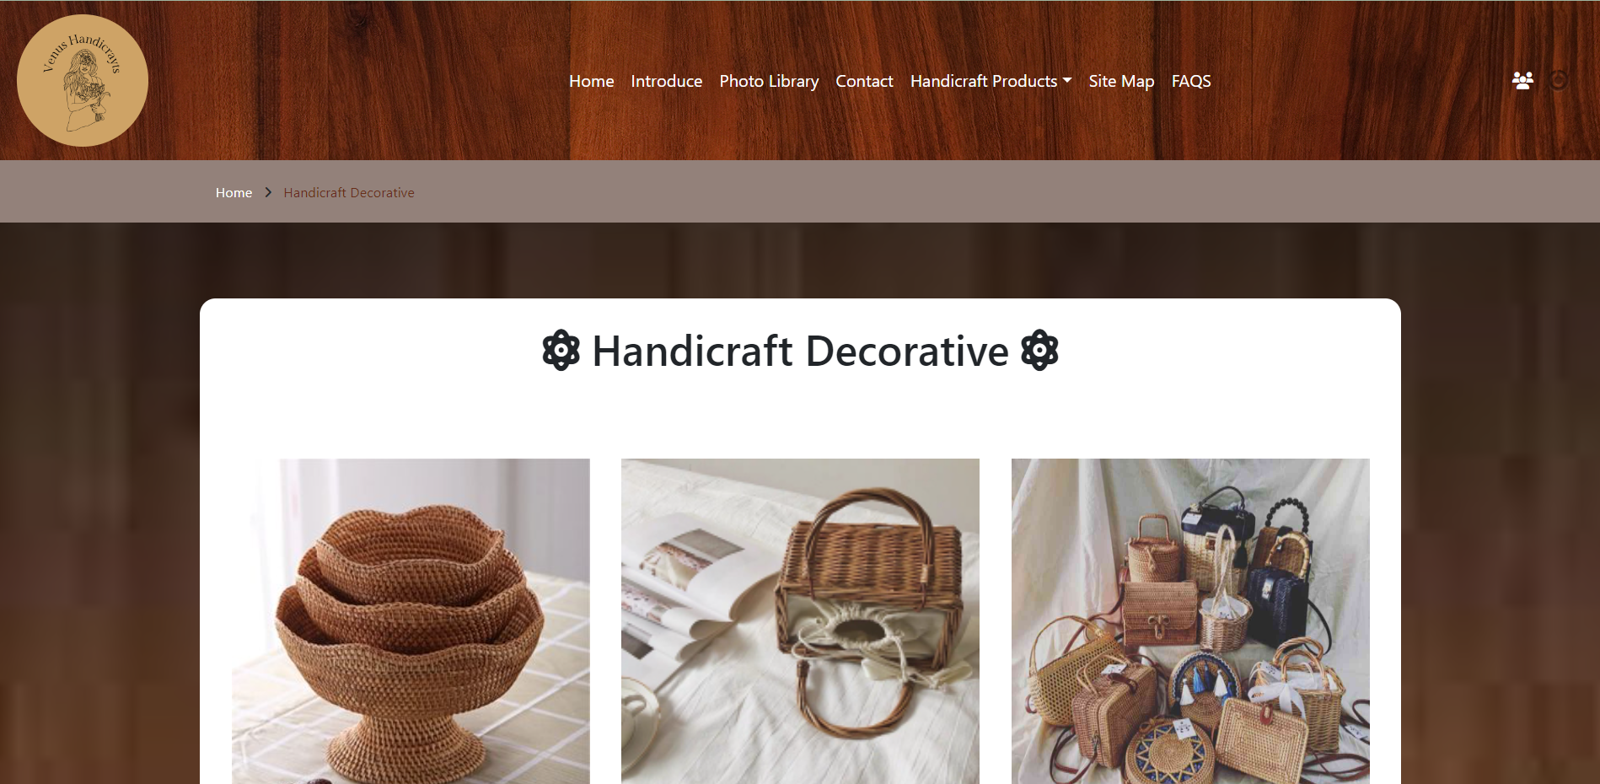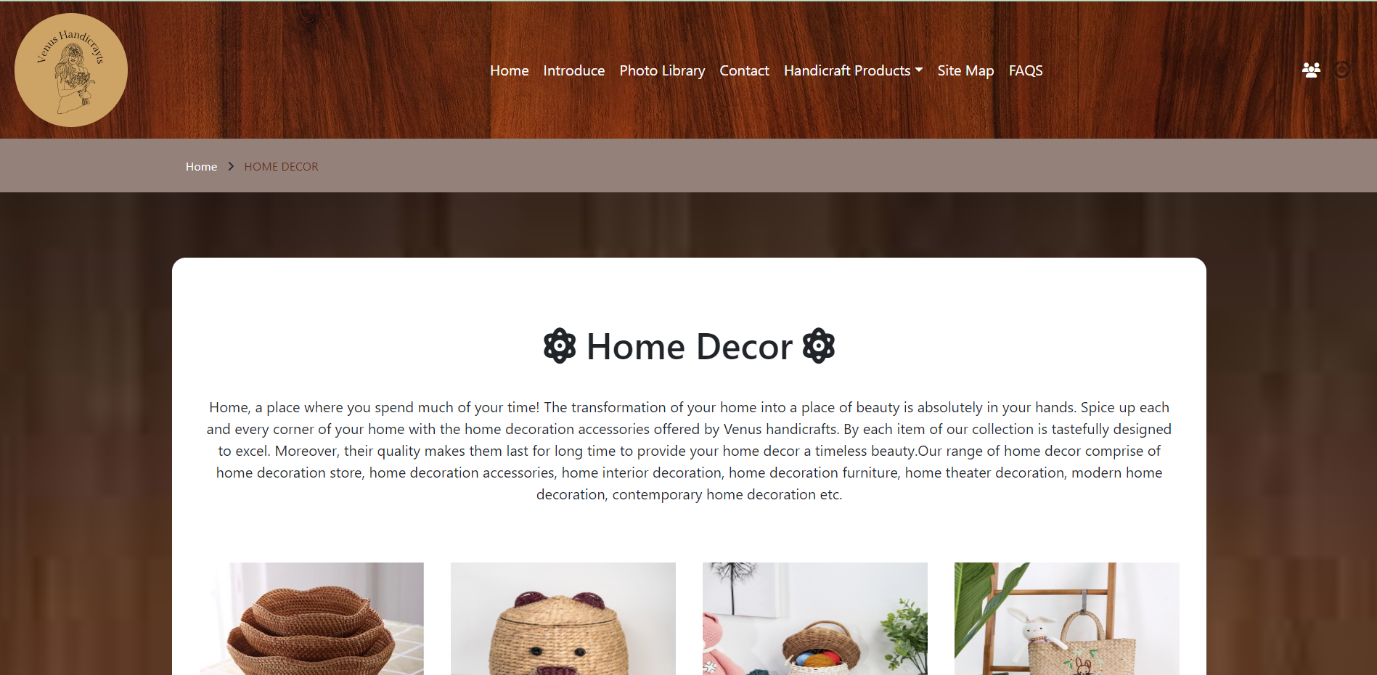

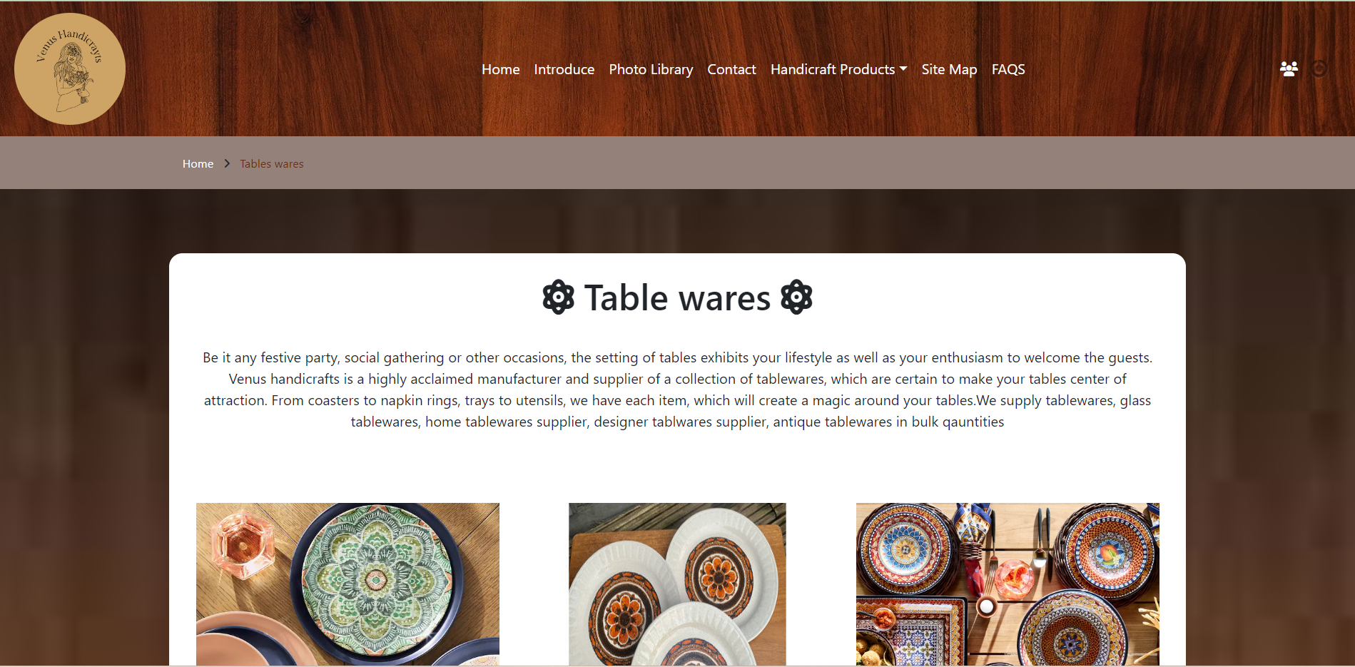

* SITE MAP

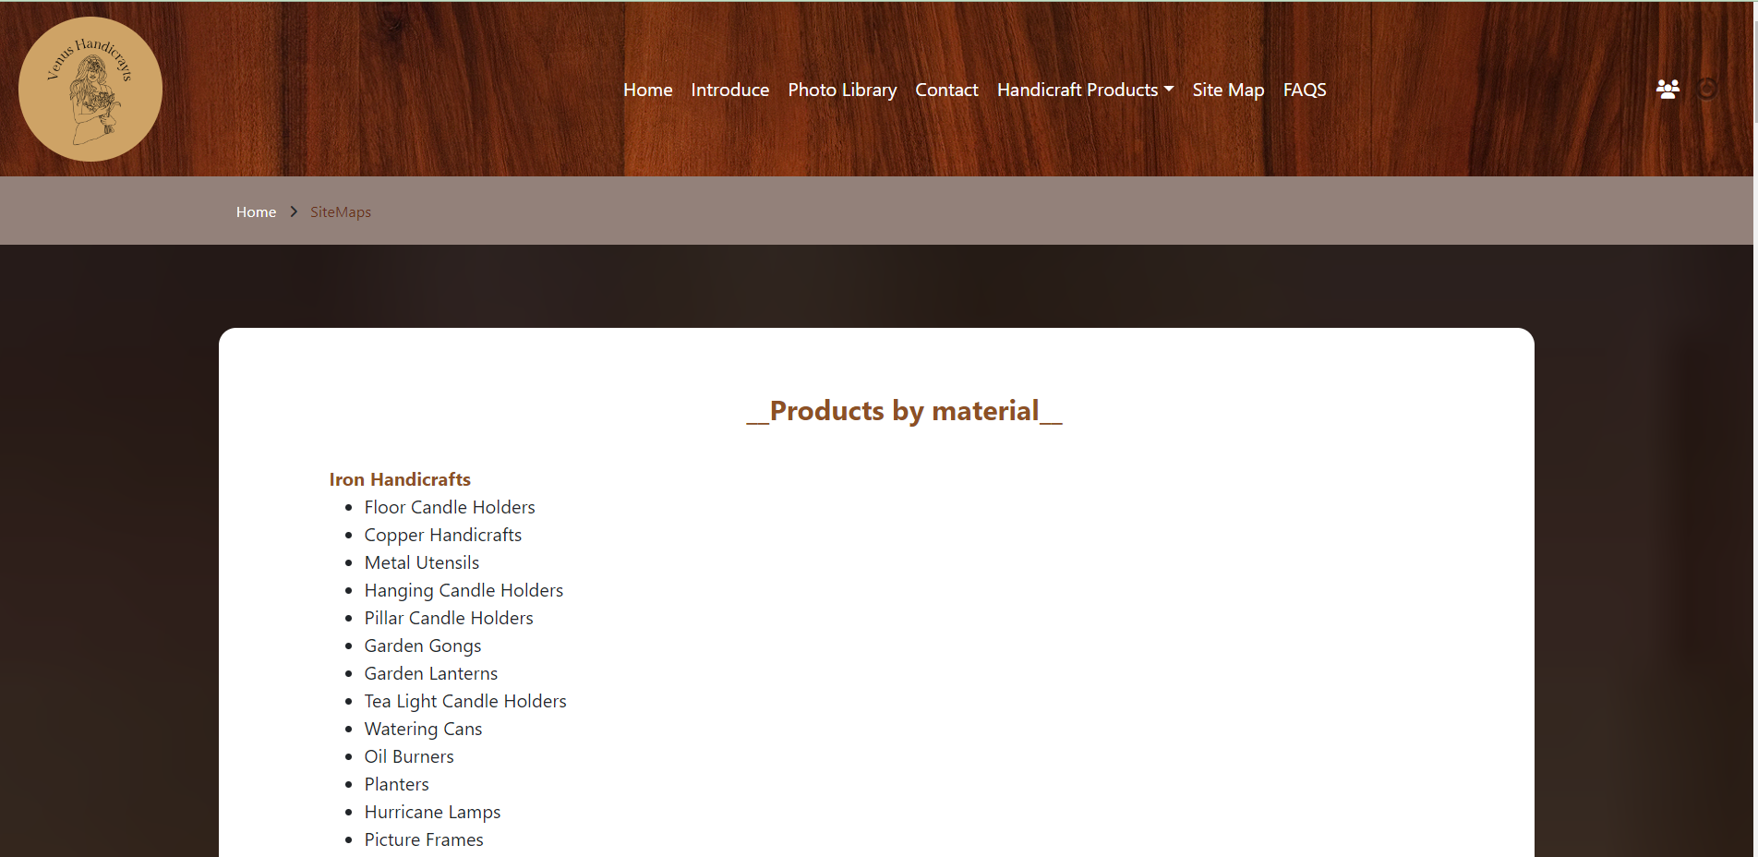

* FAQS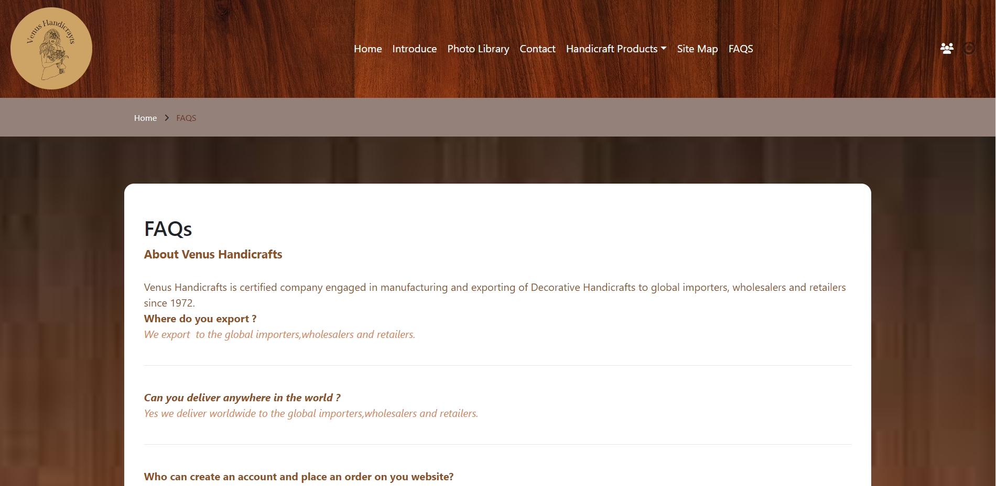
* Login

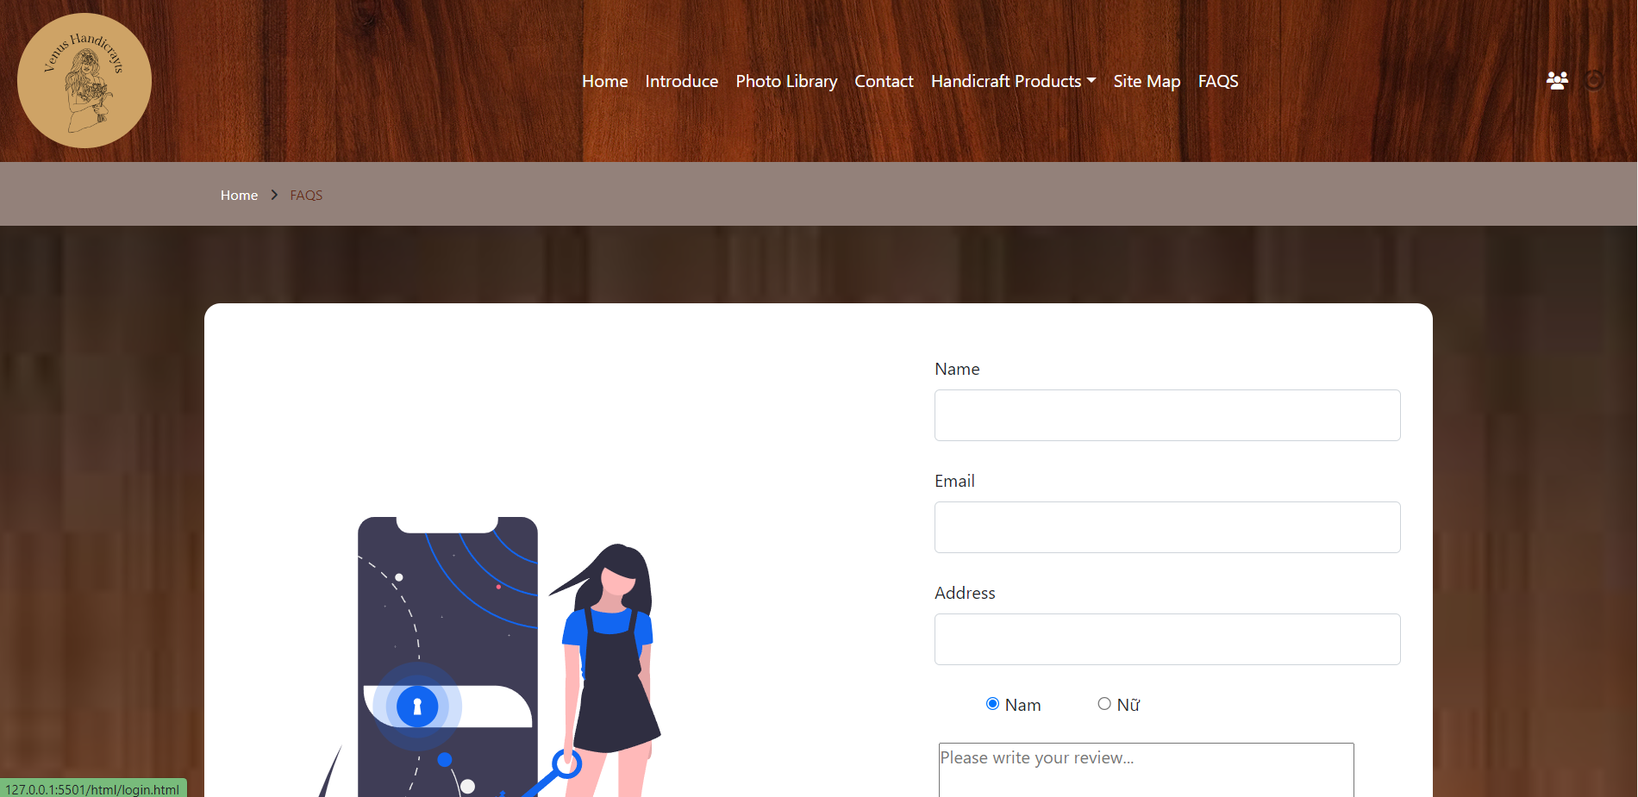

**Hope you have a good experience with our app!**

THE END. THANKS FOR READING!